**MODULE 4 EXERCISE**

**Pgm.c**

**#include<stdio.h>**

**int main() {**

**Char* str;**

**Str=”sathiya”;**

**\*(str+1)=”n”;**

**return 0;**

**}**

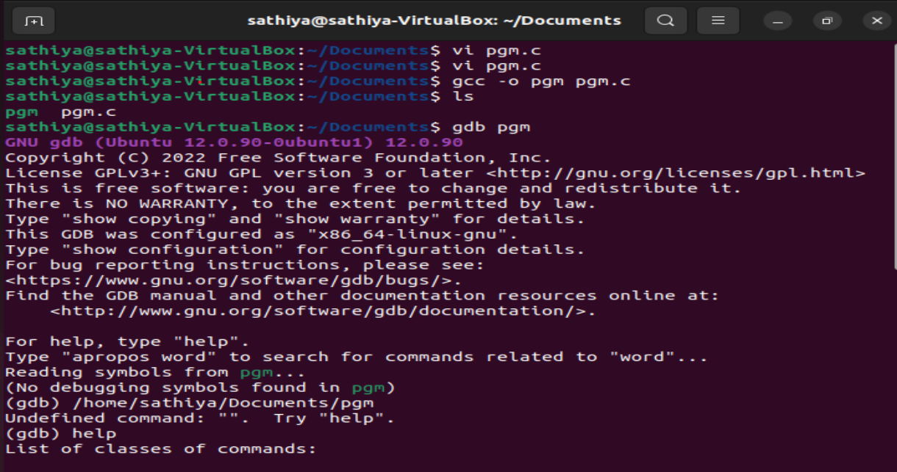

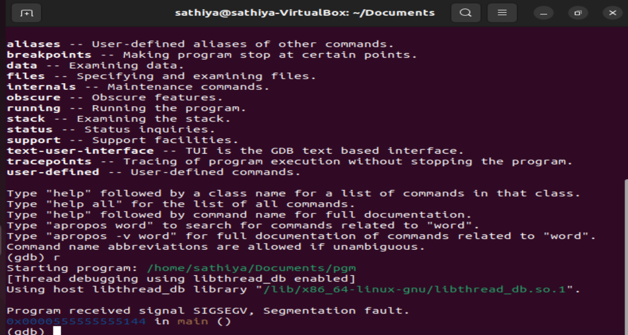

**Pgm.c**

**#include<stdio.h>**

**int main() {**

**Char* str;**

**Str=”sathiya”;**

**str=”astral”;**

**return 0;**

**}**

